Understanding Roles
Understanding Roles

Copy page

Learn the difference between Admins, Members, and Reps in Objectionly.

There are three role types in Objectionly. Two are login roles, Admin and Member, and one is a reporting profile, Rep.
​
Admin
Admin
Admins have full control of the workspace. They manage calls, reps, billing, integrations, settings, and team members. Admins always see every rep’s data.
Best for:
Workspace owners
Sales managers who need full access
Operations leads
​
Member
Member
Members can log in to view dashboards, calls, and reports, but only for reps they have been given access to. They cannot manage billing, settings, or other teammates.

Best for:
Coaches who only handle certain reps
Sales reps who want to review their own calls
Anyone who needs read access without admin controls
​
Rep
Rep
A Rep is not a login account. It is a profile that represents a salesperson whose calls are being tracked. Reps show up in dashboards, leaderboards, and reports.
A Rep profile is used for:
Attributing calls to the right person
Rep-level scorecards
Leaderboards and coaching reports
If you want a Rep to also log in, an Admin can invite them as a Member.

Managing Reps
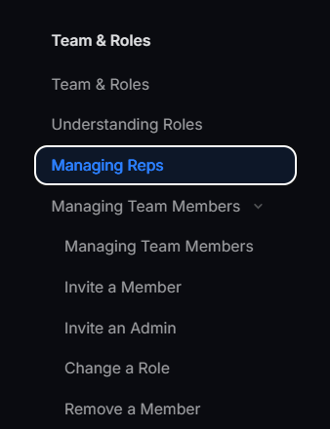
Would suggest making Managing Reps a dropdown that has Add a Rep, Edit a Rep, and Delete a Rep as 3 separate subdivisions, just to keep the format as other modules.

Managing Team Members & Rep Access
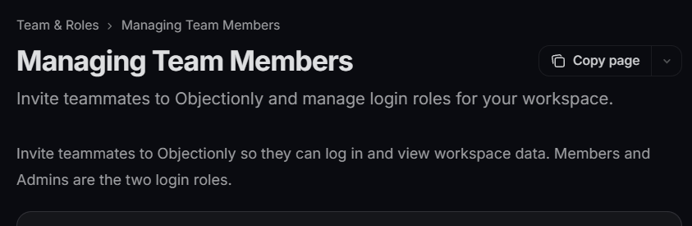
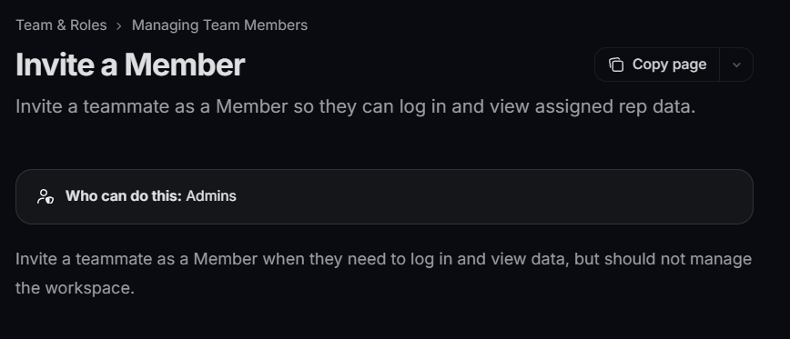
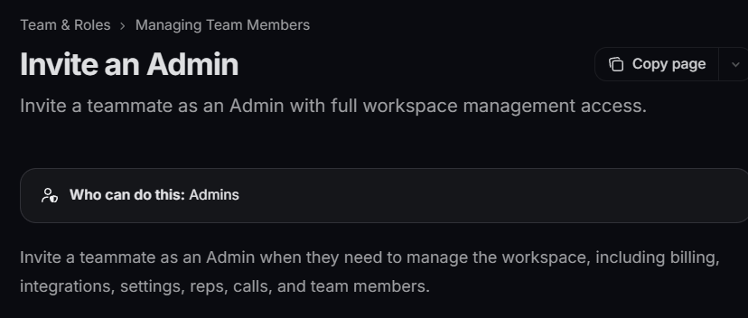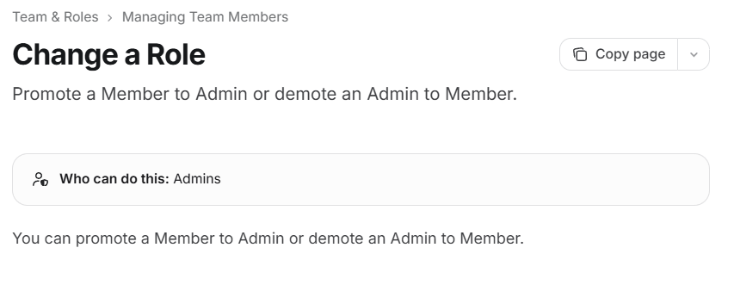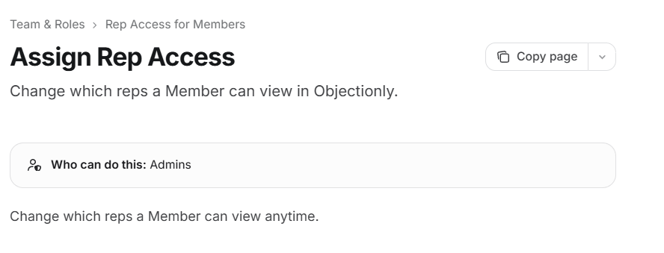

I just think there’s redundancy in the copy above. It’s just repeating the same sentence twice for each sub module, with little to no difference.

Also, in Invite an Admin the message is in yellow with a different emoji than the one in Change a Role. I think having the same design is better?

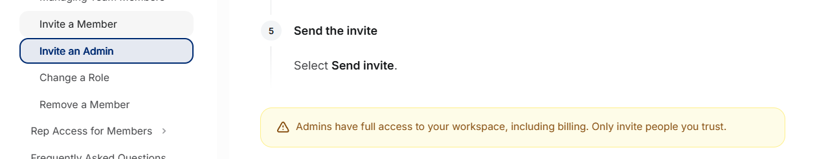

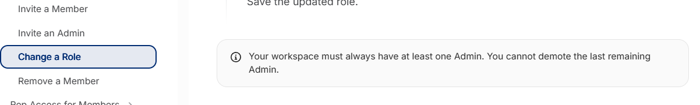

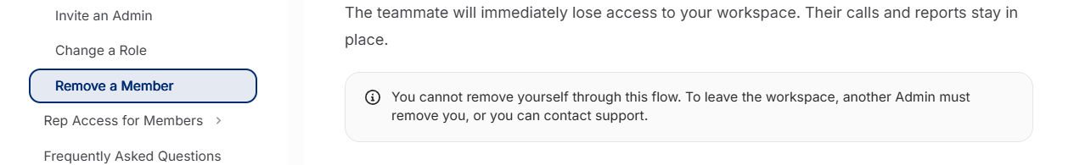

I like the one in green down btw. I just think the 3 above should have the same design since they're all the same type of callout, a warning or a note, and mixing styles makes the page feel inconsistent.

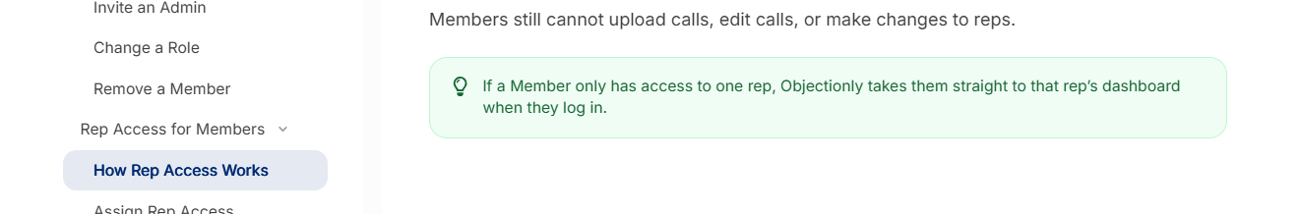

FAQs
Consider adding:
Can I give someone billing access only?
Not currently. Billing access is part of the Admin role, which also includes full access to calls, reps, and settings. If someone only needs to manage billing, they'll need to be invited as an Admin. Only invite people you fully trust.

Duration Filter
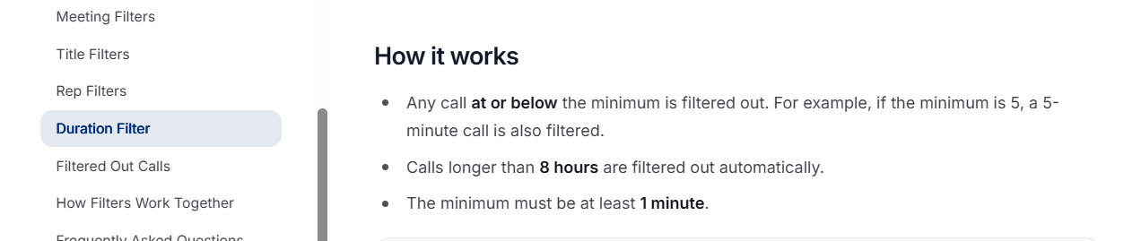

Isn’t it calls over 2 hours get filtered out? I may be wrong I’m just asking since I think I heard this from you guys some time.

